Pycnometers
Test Sheet for determining the density of a product using Pycnometers

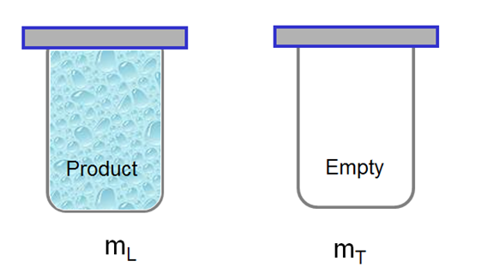
- Pycnometers certified volume = ______________

- Weigh the empty density cup and glass strike
m_{T} = _____________________

- Weigh the density cup, glass strike and product to find the product weight
m_{L} = _____________________

- Determine density p = (m_{L} – m_{T}) ÷ V

(_________________ - _________________) ÷ ________________ = ___________________

