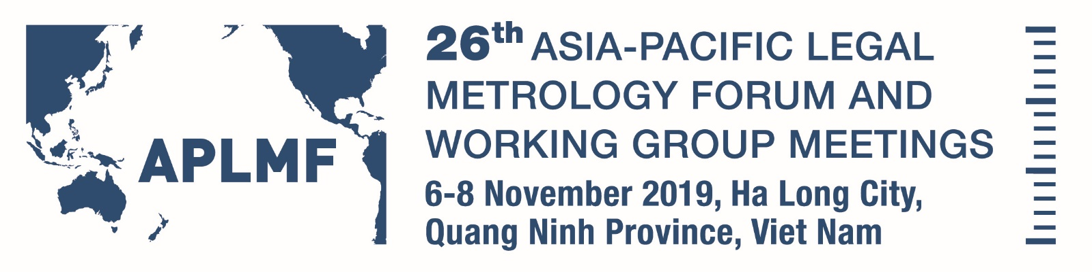

Wyndham Legend Ha Long Hotel

Hosted by Directorate for Standards, Metrology and Quality (STAMEQ)
Viet Nam
Draft Programme 16 October 2019
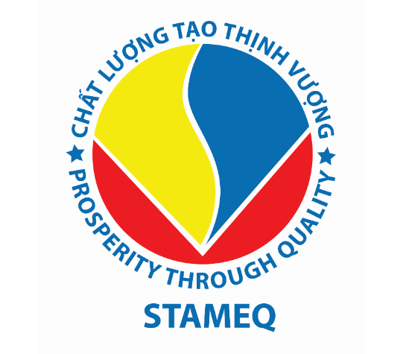

APLMF Working Groups Meeting

Date: Wednesday 6 November 2019

Time: 08:00 - 20:30

Venue: Wyndham Legend Ha Long Hotel, Diamond 1, 2nd Floor
Attending: Morning Session: Working Group members and observers
Afternoon Session: APLMF Secretariat, Executive Committee, Full Member Economies, Corresponding Member Economies, Observers, International and Regional Metrology organisations.
Chair: Stephen O’Brien

Time | Description | Facilitator/Speaker
08:00 - 08:45 | Registration | Secretariat & Hosts
08:45 - 09:00 | Welcome.-.Summary of day ahead | Mr Stephen O’BRIEN
09:00 - 10:00 | Working Groups - Workshops (Panorama 1 - 3rd Floor)  Note these workshops will be held in parallel.  - Goods Packed by Measure  - NAWI  - QMAP  - Utility Meters | Dr Rifan ARDIANTO  Ms Suliana GHAZALLI  Mr Surachai SUNGZIKAW & Ms Haslina bte Abdul KADIR  Mr WANG Lei
10:00 - 10:30 | Morning Tea
10:30 - 12:00 | Working Groups - Workshops continued
12:00 - 13:00 | Lunch and Registrations
13:00 - 13:15 | Welcome - Introductions and housekeeping | Mr Stephen O’BRIEN
13:15 - 13:45 | Secretariat Training Coordination Report | Mrs Marian HAIRE
13:45 - 14:00 | eLearning Training Modules  Update on Guide 8: How to develop an eLearning module | Mrs Marian HAIRE
14:00 - 14:15 | MEDEA 2 Update  APLMF/PTB Memorandum of Understanding | Ms Corinna WEIGELT
14:15 - 14:30 | Working Group Report: Goods Packed by Measure | Dr Rifan ARDIANTO
14:30 - 14:45 | Working Group Report: Metrological Control Systems | Mr GUO Su
14:45 - 15:00 | Working Group Report: NAWI | Ms Suliana GHAZALLI
15:00 - 15:30 | Afternoon Tea
15:30 - 15:45 | Working Group Report: OIML Certificate Systems | Mrs ZHENG Huaxin
15:45 - 16:00 | Working Group Report: Quality Measurement of Agricultural Products | Mr Surachai SUNGZIKAW
16:00 - 16:15 | Working Group Report: Utility Meters | Mr WANG Lei
16:15 - 16:30 | Subject Matter Expert Report: Medical Measurement | Mr Jin-Hai YANG
16:30 - 17:00 | Promoting Legal Metrology to the Public in Indonesia | Dr Rusmin AMIN  Director of Metrology
17:00 -17:15 | Closing Remarks, Announcements | Mr Stephen O’BRIEN  Ms Alli SMITH
18:00 - 20:00 | Welcome Dinner  Wyndham Legend Ha Long Hotel, Panorama 2, 3rd Floor  Hosted by APLMF

26th Asia-Pacific Legal Metrology Forum Meeting

Date: Thursday 7 November 2019

Time: 08:30 - 21:00

Venue: Wyndham Legend Ha Long Hotel, Diamond 1, 2nd Floor

Attending: Representatives of APLMF Secretariat, Executive Committee, Full Member Economies, Corresponding Member Economies, Observers, International and Regional Metrology organisations.
Chair: Mr Stephen O’Brien
Co-Chair: Host representative tba

Time | Description | Facilitator/Presenter
08:30 - 09:00 | Registration | Secretariat & Hosts
09:00 - 09:20 | Welcome Addresses:  Viet Nam – Leader Ministry of Science and Technology and  Leader of Quang Ninh Province tbc | tbc
09:20 - 09:30 | APLMF President’s Welcome | Mr Stephen O’BRIEN
09:30 - 09:50 | Host Presentations | tbc
09:45-09:50 | Official Group Photo
09:50 - 10:20 | Morning Tea
10:20 - 10:35 | 2020 Working Group Action Plans | Mrs Marian HAIRE
10:35 - 11:00 | Report on APLMF 2019 Work Programme and Secretariat Activities | Mr Stephen O’BRIEN
11:00-11:05 | Poster Session Instructions | Ms Alli SMITH
11:05 - 11:30 | Poster Session 1  Australia  Japan  Philippines  United States Of America | Mr Darryl HINES  Dr Tsuyoshi MATSUMOTO  tbc  Mr Ralph RICHTER
11:30 - 12:00 | Poster Session 2  Republic of Korea  Kiribati  Vietnam | tbc  Mrs Tirenga TAUEA  tbc
12:00 - 13:00 | Lunch
13:00 -14:00 | Specialist Body Reports  - International Organisation of Legal Metrology (OIML) - update  - Asia Pacific Metrology Programme (APMP) - update  - PTB, - Overview of activities in addition to MEDEA  - Asia Pacific Accreditation Cooperation (APAC) - update  - Association of Southeast Asian Nations (ASEAN) - update | Dr Charles EHRLICH  Dr Toshiyuki TAKATSUJI  Ms Corinna WEIGELT  tbc  Mr KHLAUT Ousa tbc
14:00 - 14:20 | Poster Session 3  Cambodia  Malaysia  Chinese Taipei | Mr KHLAUT Ousa  tbc  Mr Chia-Hao HSU
14:20 - 14:40 | Poster Session 4  PR China  New Zealand  Thailand | tbc  Mr Phil SORRELL  tbc
14:40 - 15:00 | Poster Session 5  Indonesia  Papua New Guinea  Singapore | Dr Rifan ARDIANTO  Mr Joe PANGA  Mrs Faith TAN
15:00 - 15:30 | Afternoon Tea
15:30 - 15:50 | Overview of 2020 APLMF Secretariat Work Programme | Mrs Marian HAIRE
15:50 - 16:10 | APMP Focus Group - Report backs  - Food Safety and Clean Water  - Energy Efficiency  - Medical Metrology  - Climate Change | Ms Haslina bte Abdul KADIR  Dr Toshiyuki TAKATSUJI  Mr Jin-Hai YANG  Mr Seung Ho BAE
16:10 - 16:50 | Panel Discussion – OIML Certification System  Mr Bill LOIZIDES - OIML  Mr XIE Jun - PR China (Issuer)  (Utiliser) tbc | Mr Phil SORRELL
16:50 - 17:00 | Wrap up and announcements | Mr Stephen O’BRIEN/Co-Chair
18:00 - 20:30 | Farewell Dinner - Muong Thanh Hotel, Ha Long  Hosted by STAMEQ  Presentations

25th Asia-Pacific Legal Metrology Forum Meeting
Full Member Only Session

Date: Friday 8 November 2019

Time: 09:00 - 11:00

Venue: Wyndham Legend Ha Long Hotel, Diamond 1, 2nd Floor

Attending: Full Members Only
Chair: Mr Stephen O’BRIEN
Time | Description | Facilitator/Presenter
09:00 - 11:00 | Introduction to Session  - Roll Call  - Secretariat Host/Presidency appointment/transition  - Membership status changes  - Secretariat Interim Financial Report Jan – Sep 2019  - MOU and Rules of Procedures – proposed update  - Confirmation of 2020 Work Programme  - Draft 2020 Budget  - Strategic Plan 2020-2025 – proposed update | Mr Stephen O’BRIEN and Secretariat
Time: 11:30 - 18:00

Venue: Wyndham Legend Ha Long Hotel, Diamond 1, 2nd Floor

Attending: APLMF Secretariat, Executive Committee, Full Member Economies, Corresponding Member Economies, Observers, International and Regional Metrology organisations.
Chair/Co-Chair: Mr Stephen O’BRIEN/tba

Time | Description | Facilitator/Presenter
11:00 - 11:30 | Morning Tea
11:30 - 12:30 | Other Business  -27th APLMF & WG – Host Economy - tbc  -28th APLMF & WG – Host Economy - tbc | Mr Stephen O’BRIEN
12:30 - 13:00 | Closing remarks by Co-Chair/Host Economy  Closing remarks by President
13:00 | Lunch
14:00 - 17:00 | Cultural Tour of Ha Long Bay (cruise)
17:15 - 18:00 | Transport back to hotel

