ASIA – PACIFIC LEGAL METROLOGY FORUM

Working Group - Goods Packed by Measure

Work Group Report for 2015

Developing of guidance for specific product types

Glazed Seafood & Growing Media Products
- Complete and has been peer reviewed by the members of the Package Goods working group
- Document has been rebranded with the APLMF logo
- Available as a word document on the APLMF website

Ice-cream
- Prototype displacement bath for small ice lollies has been developed
- Larger displacement bath for ice cream tubs up to 2 Litres to be designed and developed
- Draft procedure circulated in the next 6 months

Carbonated Liquids
- A scientific metrologist from New Zealand is researching a suitable method for determining the density of a carbonated beverage. This procedure will then be forwarded to the OIML working group on package goods (TC6), for inclusion into the OIML G14 document on density
- The intent is to develop this procedure into a APLMF guidance document
- Further information is available within the New Zealand economy report

Aerosols
- Communication has been taken place with package foods experts from the UK and South Africa. South Africa has recently purchased test equipment for determining the density of aerosols and intends to draft a report following an initial testing programme. The report will be supplied to TC6 members and detail the performance of the test equipment including, accuracy, repeatability and usability
- The Package Goods Working Group chair will circulate this report to APLMF members

MEDEA - training course on prepackage goods, May 2015, Indonesia

The Working Group Chair and a New Zealand Trading Standards Officer provided a four day training course on prepackage goods on the 18 to the 22 May 2015 in Bandung, Indonesia. The course was part of the MEDEA project and was primarily based on the OIML R79 Labelling requirements for prepackaged products and OIML R87 Quantity of product in prepackages. The training included the process required to conduct sampling, a reference test, good regulatory practice, issues to be considered when conducting a reference test, practical exercises and an onsite demonstration.

The four day course was attended by 20 delegates with the highlight of the course being the onsite visit to the Nestle manufacturing site to conduct a full reference test. This was extremely beneficial as participants were able to put into practice the knowledge learned during the classroom and apply it to a real life situation. The outcome of the onsite visit was not only positive for the participants, but also the manufacturer, who was advised that both products tested (100 g and 165 g chocolate bars) passed.

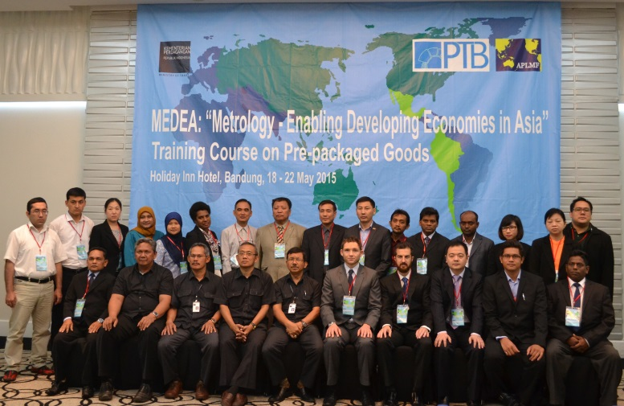
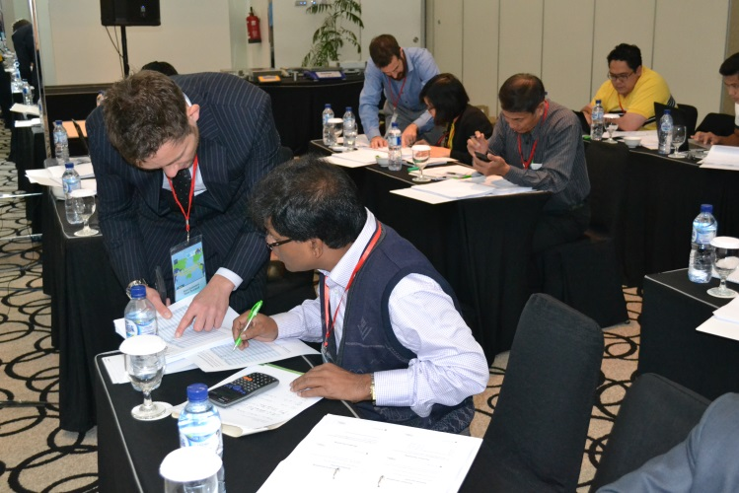
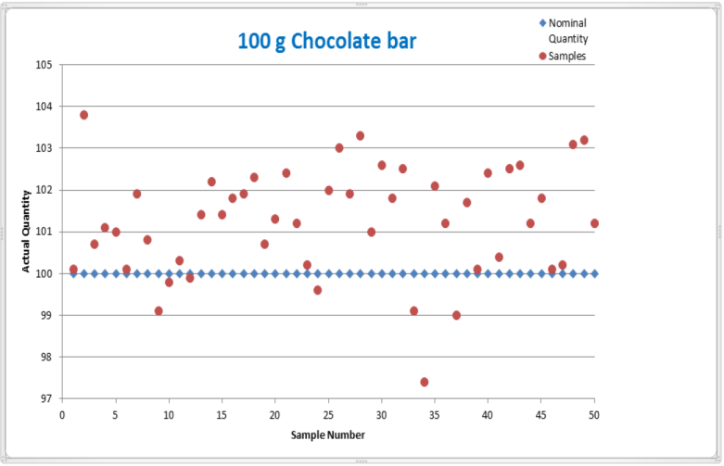
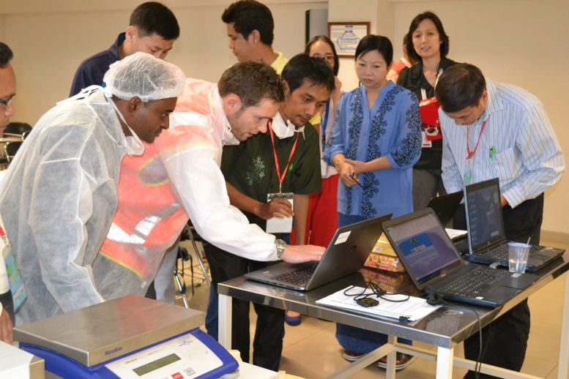

All training material developed, pictures and reports will be made available on the APLMF website.

Report on the work of OIML Technical Committee 6 (TC6) – Pre-packaged Products

Developing OIML R79 and R87

Committee Drafts for both documents have been submitted to the OIML for preliminary ballot. CIML members were afforded 3 months to vote and submit comments. The deadline for this was 24 September 2015.

The draft publication will be considered to have passed the CIML preliminary ballot stage if the majority of votes cast by CIML Members are in favour and there are no proposals or objections requiring substantial amendments of the text.

Once the draft publication has passed the CIML preliminary ballot, the BIML shall consult the convener of the Project Group to incorporate any comments received which do not require substantial amendments of the text. The BIML will then send the results of the ballot and the comments received to all CIML Members and register the publication as a ‘Final Draft’ publication and post it onto the OIML website.

OIML TC6 Project 5 ‘Guidance for Defining the System Requirements for a Certification System for Prepackages’

The purpose of the document is to provide guidance to national authorities on the establishment and maintenance of certification schemes for the control of the quantity of product in prepackages and associated labelling. An overview of this document was provided to the APLMF in the 2014 meeting in Wellington.

There has been no progress with this document since the 2014 meeting in Korea. The TC6 Secretariat has been focused on preparing R79 & R87 for the OIML preliminary ballot.

Date of next meeting

A TC6 meeting has been proposed for 2016 to progress the guidance document and to discuss developing test procedures for both carbonated liquids and aerosols.

