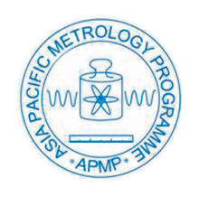
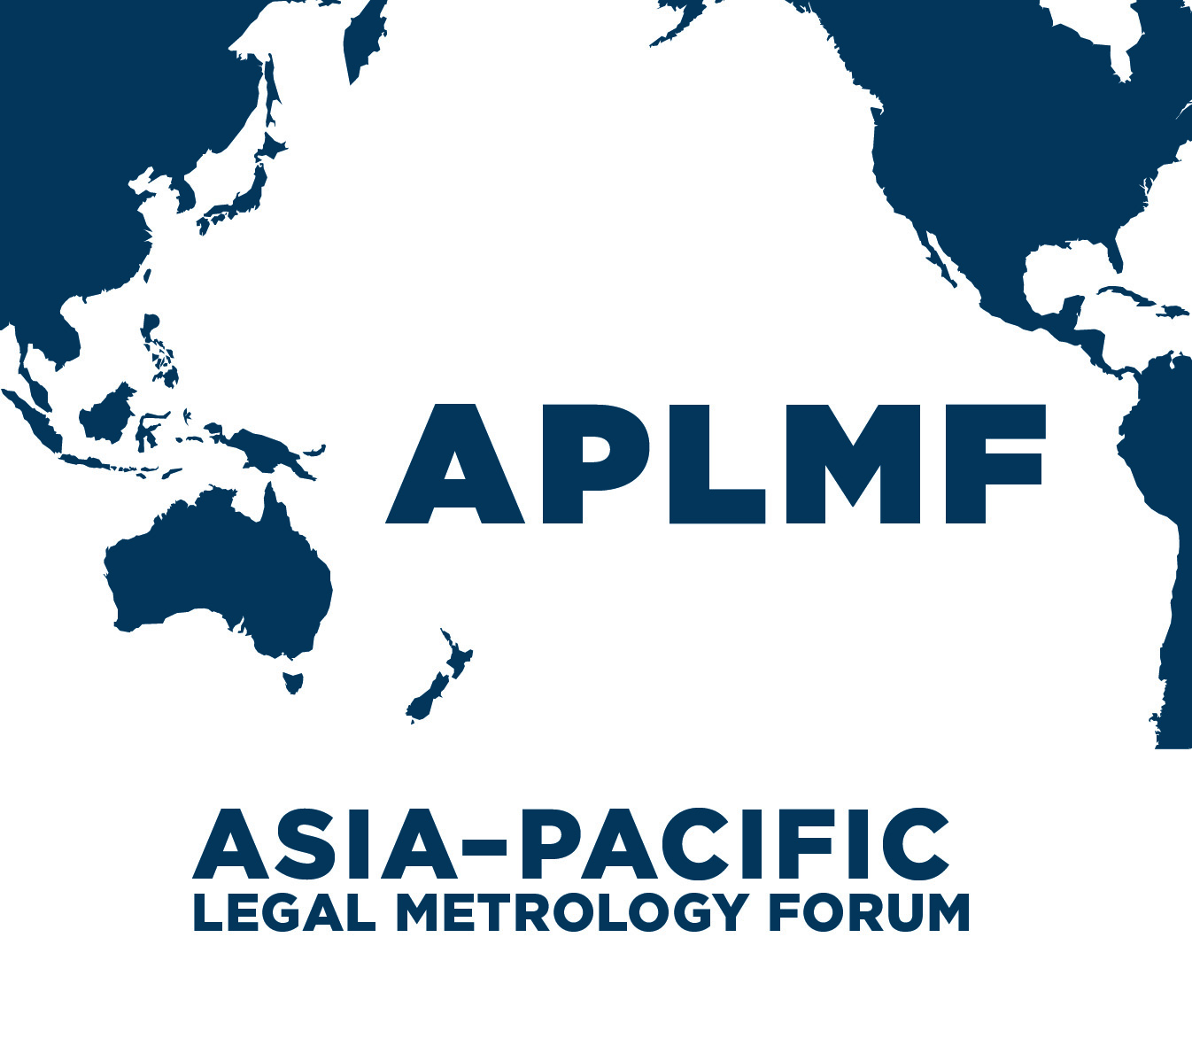

MEDEA: “Metrology – Enabling Developing Economies in Asia”

Train the Trainer Course on the Verification of BulkFlowmetering Systems using a Master Meter

24 – 27 July 2017 in Pattaya, Thailand

Introduction
Accurate measurement in the marketplace is an important component of an economy’s metrological system. APLMF has conducted training courses for the past 20 years to support the development of a sound measurement infrastructure that inspires confidence and trust within the region. This ensures both consumers and vendors are benefitting equally and promotes fairer trade with greater transparency, accuracy and long-term sustainability. Due to the high monetary value of fuel bought, sold and transferred through metering systems, it is vitally important that legal metrology authorities use harmonised verification test procedures. This train-the trainer course is designed for staff who have a responsibility to train staff in their own economies.
Objective
This program is designed for people who verify bulk flowmetering systems or who have a responsibility for ensuring that these instruments are verified in accordance with OIML recommendations. In addition to some training experience all participants are expected to have practical experience in the field using a master meter. This training is composed of lectures and practical activities. The lectures cover a basic understanding of the test procedures required to verify bulk flowmetering systems using a master meter and a volume measure as the reference standards. The practical component will demonstrate the test procedures and explain how the reference standard is verified.
This course provides participants with the knowledge and skills to:
- understand the role of trade measurement within an economy
- identify the major components of a bulk flowmetering system
- analyse the operating environment to determine how it could impact on the performance of the meter
- identify sources of any possible operational error
- verify a bulk flowmetering system in accordance with the test procedures and workplace health and safety guidelines
- train others to verify bulk flowmetering systems

Organizers:
- Physikalisch-Technische Bundesanstalt (PTB)
- Asia-Pacific Legal Metrology Forum (APLMF)
Supporting Organizations:
- Central Bureau of Weights and Measures, Thailand (CBWM)
- National Measurement Institute, Australia (NMI,A)
Trainers:
Marian Haire, Chair of WG on Training Coordination, NMIA
Brad Larter, Senior Trade Measurement Officer, NMIA
Surachai Sungzikaw, Central Bureau of Weights and Measures, Thailand
Pisakorn Pisankul, Central Bureau of Weights and Measures, Thailand
Venue and Accommodation:
  - Training will take place at the Eastern Weights and Measures Centre at Chon Buri which is located 130 km from Bangkok. Accommodation for overseas participants will be organised in the Pullman Pattaya Hotel G. The hotel will be booked and paid directly by PTB.
  - To access the venue, you will need to take the airport limousine to transfer to the hotel. The cost of the transfer will be covered by PTB. If you need a visa to enter Thailand, fill the attached “Visa Assistance Form” and send it to the host in Thailand by 15 June, 2017.

PTB Support:
Up to two overseas participants from each developing economy in Asia will receive an economy return flight ticket, free accommodation, free airport transfer and a daily allowance. Participants from economies classified as developing countries under the OECD Development Co-operation Directorate (ODCD-DAC) are eligible. Only participants from institutions that have participated in the Regional Capability Survey are eligible.
Flight tickets will be booked by PTB (please contact Jana Hennigs). The hotel will be paid directly by PTB. Participants will receive a daily allowance paid in cash during the workshop.

Presentation from each economy:
At least one participant from each economy is required to provide a brief presentation (10 minutes maximum) about the legal metrology system on bulk flowmetering systems in their economy. A guide on what to include in your presentation are shown below:

- Who you are, and your role within your organization and department
- Describe your professional experience in the area of verification of measuring instruments
- Outline the legal metrology system used to control bulk flowmetering systems in your economy
- What is the current situation in your economy about compliance to the international standards
- Describe any problems or issues you have in order to implement the legal metrology system

Registration:
Please complete the attached “Nomination Form” and send it to the APLMF Secretariat and Jana Hennigs by 28 April, 2017.

Currency and Credit Cards:
The local currency is Baht. Major credit cards (Visa, Master Card, etc) are accepted in Hotels and big department stores. The exchange rate for 1 USD is about 35 Baht.

Climate:
The average temperature is about 25ºC– 35ºC in July in Pattaya.

Electricity Supply:
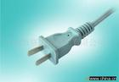
Voltage is 220-240 volts AC, 50/60 cycles per second. The power plugs used in Thailand are 2 pin Power plugs.

Local Time:
GMT +7

Contact Persons:
APLMF Secretariat
C/- Trading Standards
Ministry of Business, Innovation & Employment (MBIE)
PO Box 1473, Wellington 6140, New Zealand
Telephone: 0064-4-4601367
Ms. Alli Smith
E-mail: APLMF.Secretariat@mbie.govt.nz
PTB Contact Person:
Ms. Jana Hennigs (Registration, Flights, Hotel Reservations)
Bundesallee 100, 38116 Braunschweig, Germany
Tel: +49 531 592 8218
E-mail: jana.hennigs@ptb.de
Host in Thailand (Visa assistance, Venue and access information)
Visa assistance: Ms.Pisakorn Pisankul Email:pisankul@hotmail.com
Accommodation: Ms.Khemsai Rahannok Email: khemsair@hotmail.com and
Ms.Siriwan Gucharo Email: jik_cnn@hotmail.com
Department of Internal Trade, Central Bureau of Weights and Measures,
563 Nonthaburi Rd., T.Bangkraso, A.Muang, Nonthaburi 11000 Thailand
Tel.(66) 2547 4348
Fax.(66) 25474349

Train the Trainer Course on the Verification of Bulk Flowmetering Systems using a Master Meter
Program 24–27 July 2017

Monday 24 July Venue: Pullman Pattaya Hotel G
Time | Details | Presenter
08:30 – 09:00 | Registration | Host
09:00 – 09:40 | Welcoming address from the host economy  Opening ceremony (APLMF Secretariat)  Group photo taking | APLMF and Host
09:40 – 10:00 | Introduction | APLMF and Host
10:00 – 10:45 | Overview of the course  Economy reports - explains how bulk flowmetering systems are verified | Marian Haire  Trainees
10:45 – 11:15 | Coffee Break
11:15 – 12:30 | Economy reports continue | Marian Haire  Trainees
12:30 – 14:00 | Lunch break
14:00 – 15:30 | Brief visit to view bulk flowmetering system  Equipment required for testing  Safety considerations  Visual inspection | Surachai Sungzikaw,  Jintana Pengyai  Brad Larter
15:30 – 16:00 | Coffee break
16:00 – 17:00 | Test procedures for bulk flowmetering systems | Brad Larter
18:00 – 20:00 | Welcome dinner hosted by Central Bureau of Weights and Measures, Thailand
Tuesday 25 July Venue: Eastern Weights and Measures Center
Time | Details | Presenter
9:00 – 10:30 | Test procedures for bulk flowmetering systems | Brad Larter
10:30 – 11:00 | Coffee Break
11:00 – 12:30 | Test procedures for bulk flowmetering systems | Brad Larter
12:30 – 14:00 | Lunch
14:00 – 15:30 | Demonstration of test procedures and completion of test report | All trainers
15:30 – 16:00 | Coffee Break
16:00 – 17:00 | Demonstration of test procedures and completion of test report Question and Answer session | All trainers
Wednesday 26 July Venue: Eastern Weights and Measures Center
Time | Details | Presenter
9:00 – 10:30 | Demonstration of test procedures and completion of test report | All trainees
10:30 – 11:00 | Coffee Break
11:00 – 12:30 | Students work together to answer test questions | All trainers
12:30 – 14:00 | Lunch
14:00 – 15:30 | Group discussion of answers to test questions | Brad Larter  Marian Haire
15:30 – 16:00 | Coffee Break
16:00 – 17:00 | Preparation for group presentations  Action plans | All trainers
Thursday 27 July Venue: Eastern Weights and Measures Center
Time | Details | Presenter
9:00 – 10:30 | Group 1 presentations – Discussion and feedback | Participants
10:30 – 11:00 | Coffee Break
11:00 – 12:30 | Group 2 presentations – Discussion and feedback | Participants
12:30 – 13:30 | Lunch
13:30 – 15:00 | Group 3 presentations – Discussion and feedback | Participants
15:00 – 15:30 | Coffee Break
15:30 – 17:00 | Group 4 presentations – Discussion and feedback | Participants
17:00 – 17:30 | Closing Ceremony | APLMF and Host
18:00 – 20:00 | Farewell dinner hosted by MEDEA

see http://www.oecd.org/dac/stats/daclist.htm. Eligible economies in Asia: Bangladesh, Bhutan, Cambodia, Fiji, India, Indonesia, Kyrgyzstan, Laos, Malaysia, Mongolia, Myanmar, Nepal, Pakistan, Papua New Guinea; Philippines, Sri Lanka, Thailand, Uzbekistan, Vietnam
Only economies that submitted the Regional Capability Survey are eligible to receive funding by the MEDEA project.

