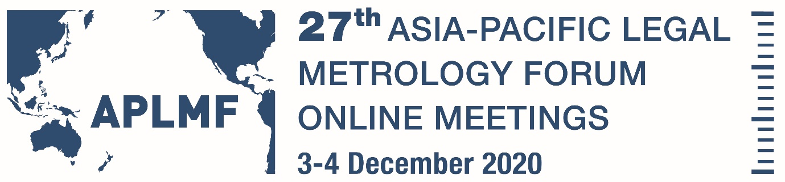

Synopsis of Presentations Thursday December 3rd

Software Examination for Legal Metrology in Malaysia
Presenter: Mr Muhammad Azwan Ibrahim, Senior Metrologyist, National Metrology Institute of Malaysia (NMIM)
- Introduction
- History and current status
- Capability development
- Motivation
- Instruments under examination
- Documents analysis and requirements
- Reporting of software examination
- Summary
Conformity to Type (CTT) Market Surveillance - Regional Pilot
Presenter: Mr Darryl Hines, Manager-Policy and Regulatory Services, National Measurement Institute Australia (NMIA)
Progress on what testing has occurred and generic outcomes and observations

Internet of things and how networking of Instruments is changing metrology
Presenter: Dr Roman Schwartz, President, International Organization of Legal Metrology (OIML)
- What is meant by 'Internet of Things'?
- How developed simple measuring sensors / instruments to complex measuring systems integrated into networks?
- What are the consequences and chances of this development for the market participants (manufacturers, users, etc.)?
- What is meant by 'Digital transformation of metrology', why is it necessary, what aspects does it involve?
- How is this connected to the digital transformation of Quality Infrastructure (QI)?
- What effects of digitization are to be expected specifically for legal metrology?

