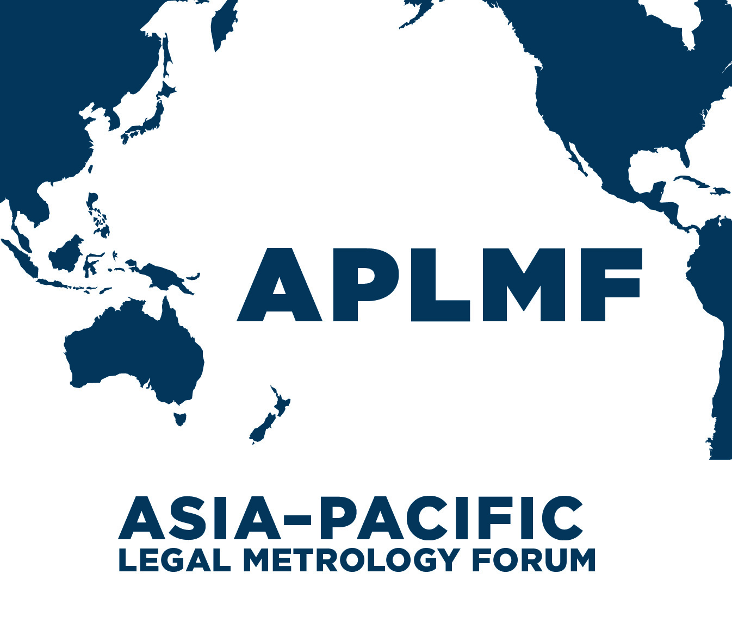
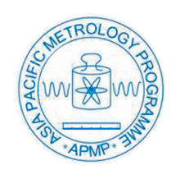

MEDEA: “Metrology – Enabling Developing Economies in Asia”

Pattern Approval and Verification of Water Meters – OIML R49

15 – 18 October 2019 at NMIM, Sepang, Malaysia

Introduction
Accurate measurement of water metering for residential and commercial buildings is one of many important components of an economy’s metrological system. APLMF has conducted training courses for the past 20 years to support the development of a sound measurement infrastructure that inspires confidence and trust within the region. This ensures consumers, water authorities and water meter manufacturers are benefitting equally and promotes fair trade with greater transparency, accuracy and long-term sustainability. Due to the rising costs, the need for quality and the supply demand of water for urban use, it is important that legal metrology authorities use harmonised verification test procedures to ensure accurate measurement systems. This training course is designed for personnel with responsibility to develop an appropriate metrological infrastructure for testing of water meters in their own economies. Participants are expected to train others when they return to their own economy.
Objective
This program is designed for authority personnel who approve / verify water meters for use in urban water systems or have responsibility to ensure that these instruments are pattern approved / verified in accordance with OIML recommendations. In addition, participants are expected to have prior hands-on practical experience in a laboratory testing of water meters. This training is composed of lectures and practical activities. The lectures cover a basic understanding of the test procedures required to pattern approve and verify water meters for use in urban systems as per OIML R49. The practical component will demonstrate the test procedures used and explain how the reference standard is verified.
This course provides participants with the knowledges and skills to:
- identify the major components of a water meter testing system
- analyse the operating environment to determine how it could impact on the performance of a water meter
- identify sources of any possible operational error
- pattern approve / verify a water meter in accordance with the test procedures and workplace health and safety guidelines

Organizers:
- Physikalisch-Technische Bundesanstalt (PTB)
- Asia-Pacific Legal Metrology Forum (APLMF)
Supporting Organizations:
- National Metrology Institute of Malaysia (NMIM)
Trainers:
Dr Abdul Rahman Mohamed
Mr Mohd Noor Mohd Ghaffar
Mr Hafidzi Hamdan
Venue and Accommodation:
Training will take place for overseas participants at the hotel and the National Metrology Institute of Malaysia (NNIM). Accommodation will be organised in the Nilai Springs Hotel. The hotel will be booked and paid directly by PTB.
Arrangements will be provided later regarding your transfer to the hotel. The cost of the transfer will be covered by PTB. If you need a visa to enter Malaysia, fill the attached “Visa Assistance Form” and send it to the host in Malaysia by 14 September 2019.
To access the venue, you will need to take the airport shuttle to transfer to the hotel. Please note that the driver will wait at the exit of the baggage claim area. Please look at a placard with PTB, NMIM, APMP & APLMF logo at the Airport Taxi counter after baggage claim point. The cost of the transfer will be covered by PTB.

PTB Support:
Up to two overseas participants from each developing economy in Asia will receive an economy round-trip flight ticket, free accommodation (full board), free airport transfer. Participants from economies classified as developing countries under the OECD Development Co-operation Directorate (ODCD-DAC) are eligible. Economies are required to consider contributing (if they can do so) to their expenses.
Flight tickets will be booked by PTB (please contact Catharina Watzl). The hotel will be paid directly by PTB.

Registration:
Please complete the attached Nomination Form and send it to the APLMF Secretariat and Catharina Watzl by 14 August 2019.
The official currency is Ringgit (MYR). Most credit cards (Visa, Master Card, etc.) are accepted in Hotels and big department stores. The exchange rate for 1 USD is around MYR 4.4.

Climate:
The average temperature range is about 24-33°C in July in Kuala Lumpur.
Electricity supply:
Voltage of power supply is 220 volts AC with 50 Hz. The power plug used in Malaysia are 3 pin plugs of type G (or BF).
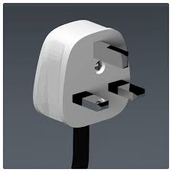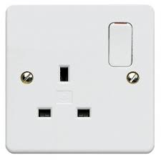
Plug and socket of Type G (or BF)
Local Time:
UTC +8 without summer time

Contact Persons:
  - APLMF Secretariat
C/- Trading Standards
Ministry of Business, Innovation & Employment (MBIE)
PO Box 1473, Wellington 6140, New Zealand
Telephone: 0064-4-4601367
Ms. Alli Smith
E-mail: secretariat@aplmf.org
  - PTB Contact Person:
Mrs. Catharina Watzl (Registration, Flights, Hotel Reservations)
Bundesallee 100, 38116 Braunschweig, Germany
Tel: +49 531 592 8246
E-mail: catharina.watzl@ptb.de

Host in Malaysia (visa assistance, venue and accommodation)
Mr. Zainal Hj. Mustapa
National Metrology Institute of Malaysia - NMIM
Lot PT 4803 Bandar Baru Salak Tinggi,
43800 Sepang, Selangor, Malaysia
Tel: +603 8778 1607
H/p: +6014 2262 449
Fax: +603 8778 1616
E-mail: zainalm@sirim.my
Pattern Approval and the Verification of Water Meters
Program 15 –18 October 2019

Tuesday 15 October Venue: Nilai Springs Hotel
Time | Details | Presenter
08:30 – 09:00 | Registration | Host
09:00 – 09:40 | Welcoming address from the host economy  Opening ceremony (APLMF Secretariat)  Group photo taking | APLMF and Host
09:40 – 10:00 | Introduction | APLMF and Host
10:00 – 10:30 | Overview of the course  Economy reports - explains how water meters are tested & verified | Marian Haire and  Trainees
10:30 – 11:00 | Coffee Break
11:00 – 12:30 | Course outline  - History of Water Meters  - Types and uses of Water Meters | Dr Abdul Rahman
12:30 – 14:00 | Lunch break
14:00 – 15:30 | OIML R49 - 1 and International Standards | Dr Abdul Rahman
15:30 – 16:00 | Coffee break
16:00 – 17:00 | OIML R49 - 2 & 3 | Dr Abdul Rahman
18:00 – 20:00 | Welcome dinner hosted by MEDEA
Wednesday 16 October Venue: Nilai Springs Hotel and NMIM
Time | Details | Presenter
9:00 – 10:30 | Test procedures for Pattern Approval and the Verification of Water Meters  - Sample of Water Meters by group  - Sample of Test Sheet | Mohd Noor/Hafidzi
10:30 – 11:00 | Coffee Break
11:00 – 12:30 | *Demonstration data process (3 groups) | Mohd Noor/Hafidzi
12:30 – 14:00 | Lunch + shuttle bus to NMIM
14:00 – 15:30 | *Demonstration of test procedures and completion of test report | All trainers
15:30 – 16:00 | Coffee Break
16:00 – 17:00 | *Demonstration of test procedures and completion of test report Question and Answer session | All trainers
*Demonstration:
- Accuracy Test performed by each group
- Demonstration of continuous and non-continuous performed by trainer

Thursday 17 October Venue: Water Meter Factory visit
Time | Details | Presenter
9:00 – 9:30 | Bus to venue | All trainees
9:30 – 10:30 | Visit to Water Meter Factory to view their facilities | All trainees
10:30 – 11:00 | Coffee Break
11:00 – 12:30 | Visit to Water Meter Factory to view their facilities | All trainees
12:30 – 14:00 | Lunch
14:00 – 15:30 | Action plans and feedback | Marian Haire trainers
15:30 – 16:00 | Coffee Break
16:00 – 17:00 | Trainees answer test questions and prepare group presentation for Friday am | All trainees
18:00 – 20:00 | Outdoor Dinner - Nilai Spring Hotel | All trainees
Friday 18 October Venue: Nilai Springs Hotel
Time | Details | Presenter
9:00 – 10:30 | Presentation by each group | All trainees
10:30 – 11:00 | Coffee Break
11:00 – 12:30 | Closing ceremony with bestowal of the certificates | All trainees
12:30 – 14:00 | Lunch

see http://www.oecd.org/dac/stats/daclist.htm. Eligible economies in Asia: Bangladesh, Bhutan, Cambodia, Fiji, India, Indonesia, Kyrgyzstan, Laos, Malaysia, Mongolia, Myanmar, Nepal, Pakistan, Papua New Guinea; Philippines, Sri Lanka, Thailand, Uzbekistan, Vietnam

